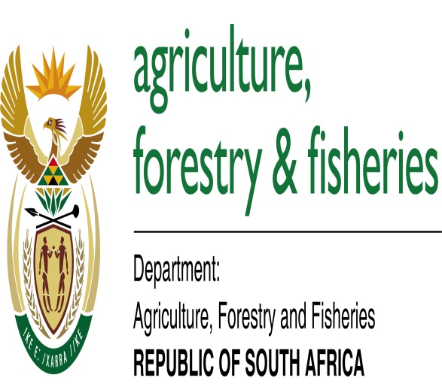

The LandCare National Assessment Panel for 2018/19 Projects
From the 20th to the 21st of November 2017, the National LandCare Secretariat hosted all provincial Departments of Agriculture for the 2017 LandCare National Assessment Panel for the 2018/19 LandCare project in Imbizo Hall. The purpose of the 2017 LandCare National Assessment Panel was to approve LandCare provincial business plans for the 2018/19 financial year. All provinces presented their business plans based on the template provided by the national LandCare Secretariat for uniformity. The chairperson of the National LandCare Assessment Panel, Mrs L Bosoga, welcomed all the provincial and national delegates to the meeting were she outlined the purpose of LandCare National Assessment Panel, which is to adhere to the DORA prescript that require the hosting of the Provincial Assessment Panel and the National Assessment Panel before the approval of the implementation of all Schedule Five programmes which the LandCare conditional grant is part of. Mr RK Mampholo gave a presentation about the observation of the Department Of Agriculture, Forestry and Fisheries when it comes to the implementation of the LandCare projects by provinces and what provinces should do in order to effectively improve the implementation of the LandCare conditional grant. Over the course of two days, the provinces presented their plans for the implementation of the LandCare conditional grant in their respective provinces for the 2018/19 financial year. The panel members recorded their comments on the scoring sheet which will be used to approve or not approve of the projects. It was agreed during the assessment that the national LandCare Secretariat will consolidate the comments from the panellists and send it to the province so that they can make adjustments to their provincial business plans before they can send the Final Business Plan to the national LandCare Secretariat for approval. All nine provinces were present to present their business plans.
